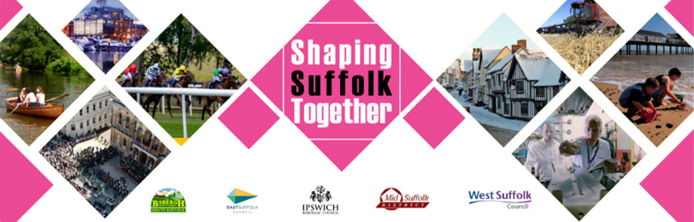

Shaping Suffolk Together

Local Government Reorganisation – Easy Read

What is happening?

The Government wants to change how councils work in England.

Councils now

In some places, there are two types of councils:

- district councils – look after things like parks, bins, housing, and food safety

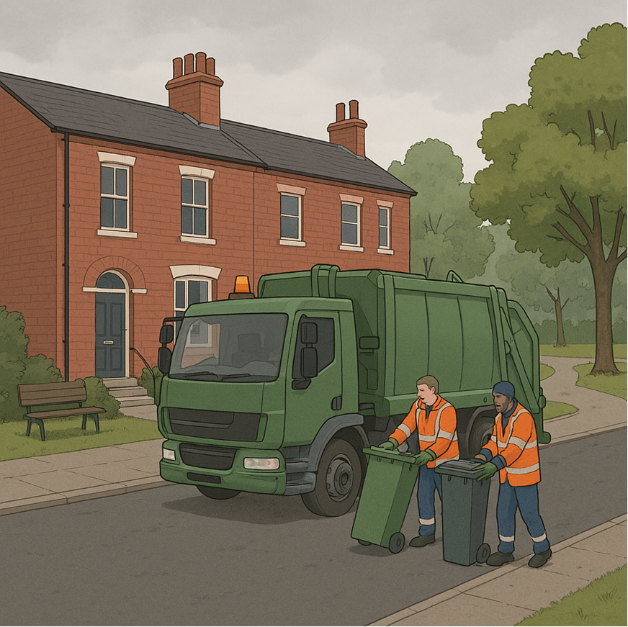
- county councils – look after things like schools, roads and help people who need extra care.

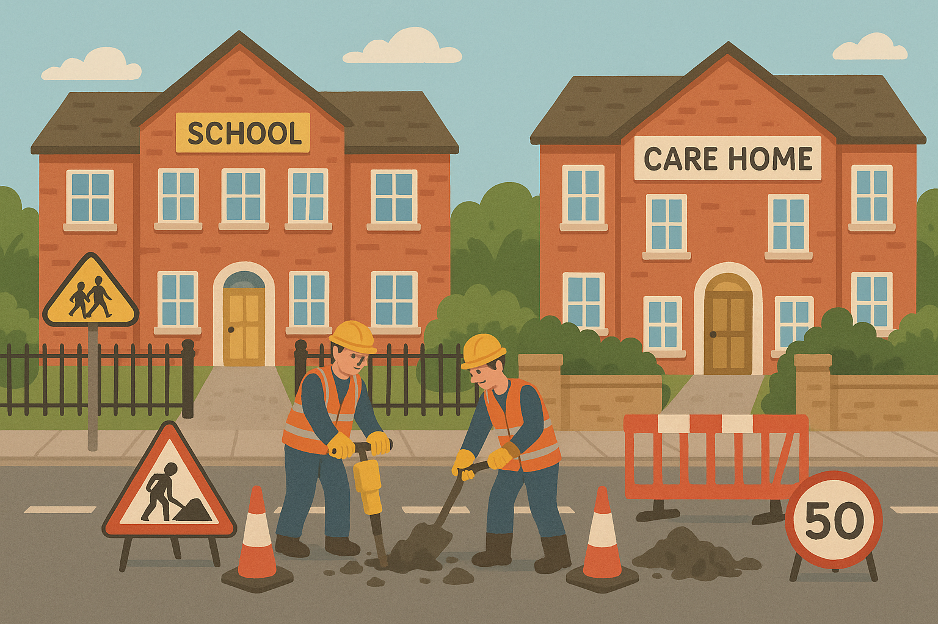

In Suffolk:

- district councils cover areas like Ipswich or West Suffolk

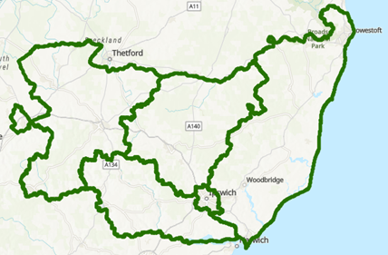

- Suffolk County Council covers the whole county.

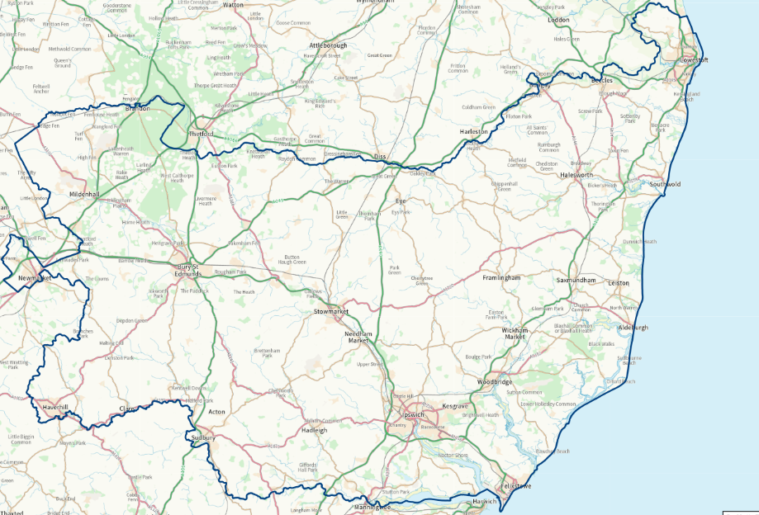

What might change?

The Government wants just one council in each area. This is called a unitary council.

A unitary council would do all the jobs that district and county councils do now.

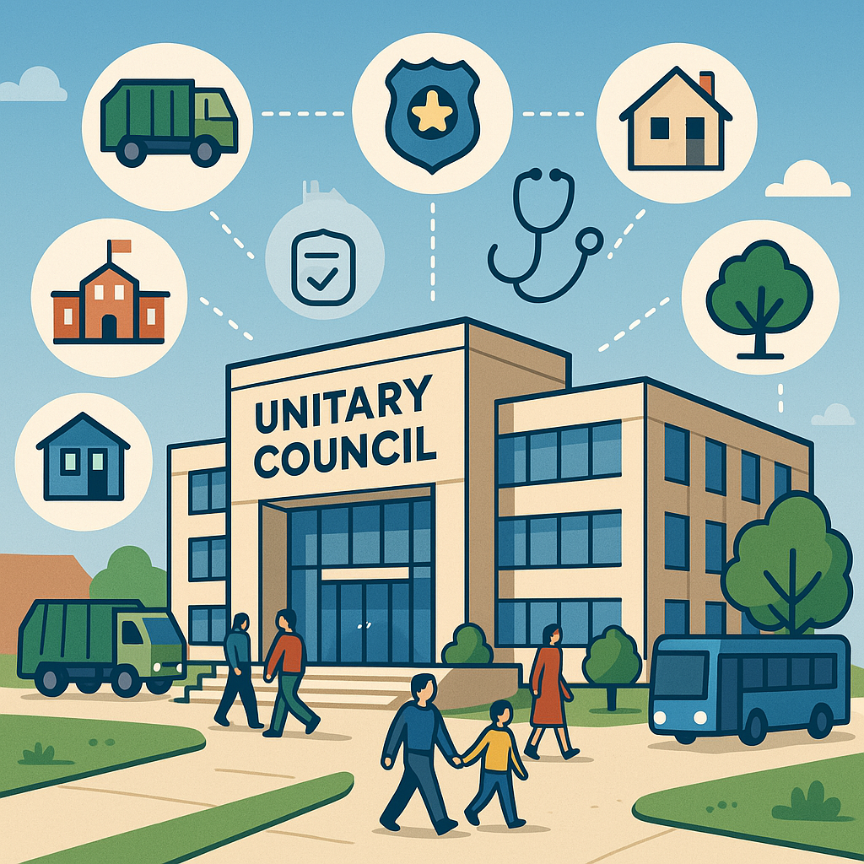

What are people saying?

Councillors in Suffolk are thinking about:

- having one big council for all of Suffolk, or

- having three smaller councils.

They will send their ideas to the Government in September 2025.

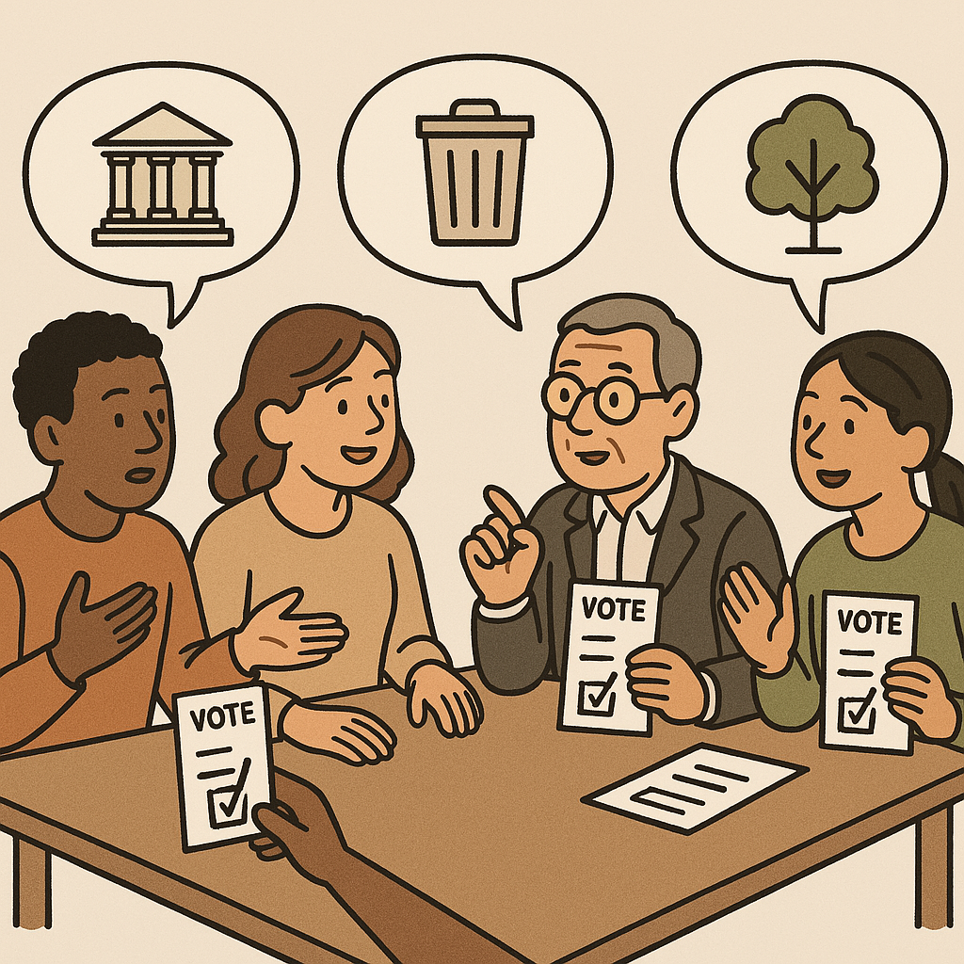

Three smaller councils would cover the areas in this map:

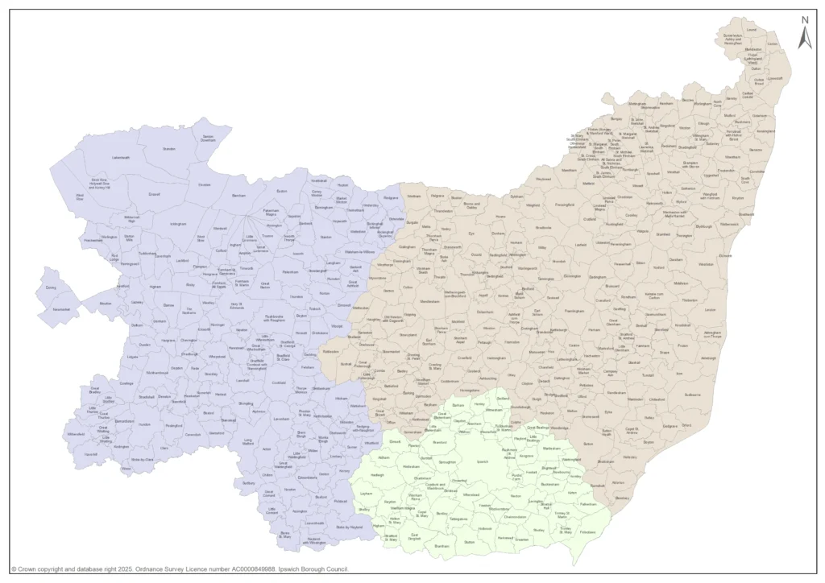

What happens next?

The Government will decide what to do.

The new councils will start in 2027 or 2028.

What do the district councils think?

They think having three smaller councils would be better because:

- The people working for the council would know more about the local area

- It would be easier for people to have a say in decisions.

What can you do?

You can share your views!

Call the Customer Services Team at your district council and ask to speak to the Policy Team about Local Government Reorganisation.



Some images generated by artificial intelligence

